# queens logo.jpgTeaching Early Social Communicative Skills to Young Children with Autism

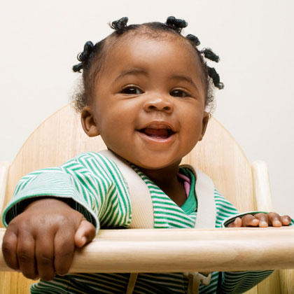

**IfIf**

**If not, your child may be eligible to participate in a research study examining an intervention to teach your child fundamental early social communicative skills!**

**Does your child share his/her excitement with you?**

**Does your child imitate you or others?**

**Does your child make eye contact?**

## The Developmental Disabilities Lab at Queens College, CUNY is recruiting children with a diagnosis on the Autism Spectrum.

* **We will meet with you and your family, assess your child’s skills, and explain intervention strategies.**
* **We will work with you and the members of your child’s team to implement the teaching strategies.**
* **Intervention will take place in your home, your child’s school, or at Queens College.**

**If you are interested in learning more, please contact**

**the Developmental Disabilities Lab at Queens College at**

**718-997-3206 or DDLab@qc.cuny.edu**